**Docker Swarm service**

*Docker swarm is an orchestration service within docker that allows us to manage and handle multilple containers at the same time

*it is used to manage the containers on multiple servers

*docker engine helps to create docker swarm

*thera are mainly worker nodes and manager nodes

*the worker nodes are connected to the manager nodes

*each worker node work on individual service fro better performance

*mangaer nodes are used to devide the work among the workers nodes

**Setup;**

Create 3 node one is manager and 2 are wokers manager nodes

Manager node named as server

Worker nodes are named as slve 1 and 2

**CONNECT TO SERVER**

*yum install docker –y

*systemctl docker –y

*Hostnamectl hostname manager

*ll

*hostname manager

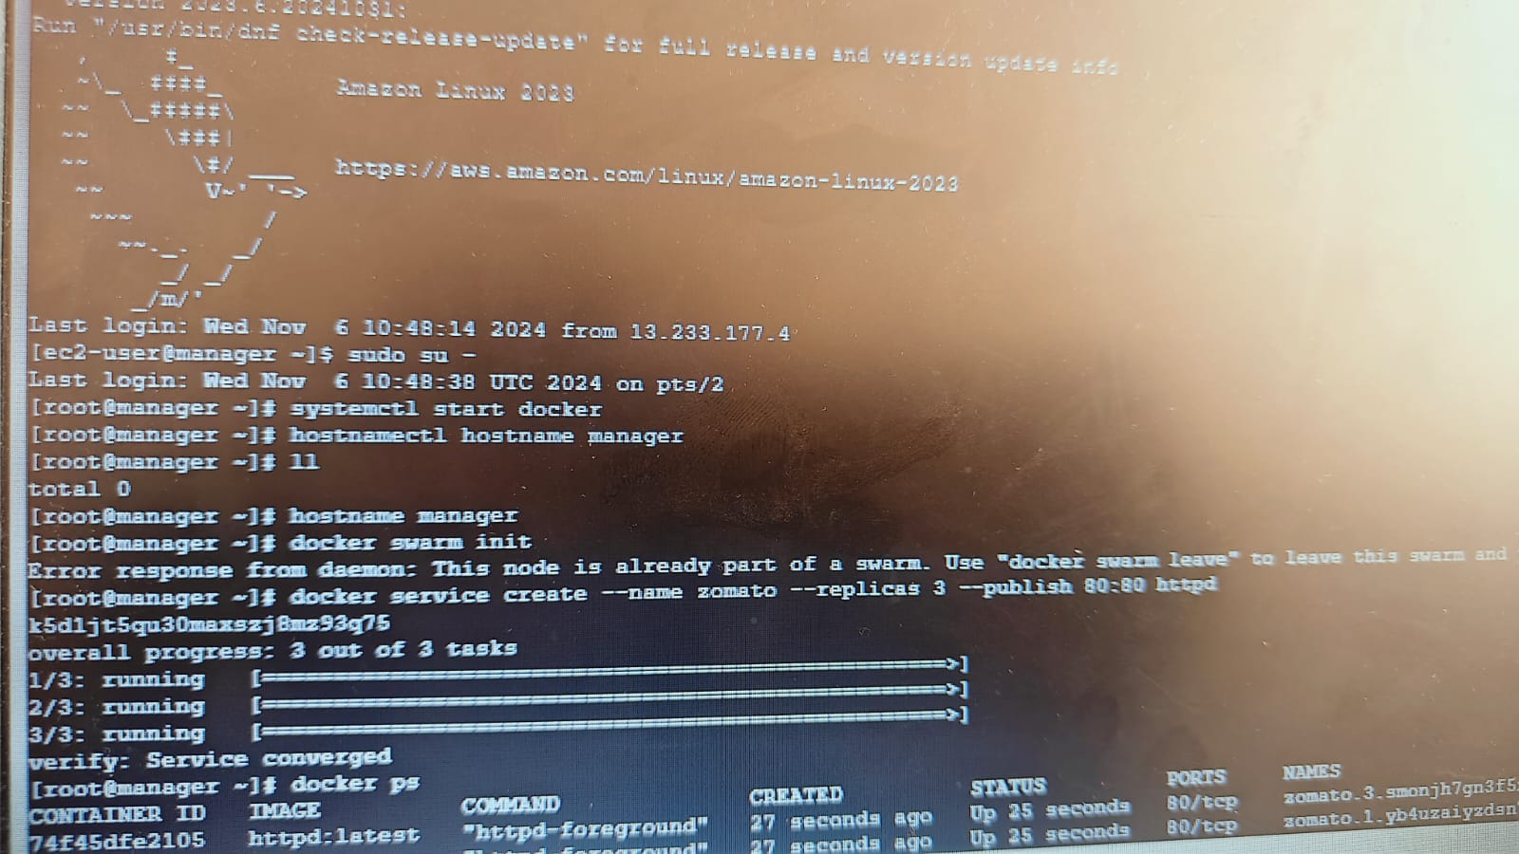

**GOTO SLAVE 2**

* ALLOW ALLTRAFFIC

**GO TO SERVER**

* **Docker swarm init**

**GO TO SLAVE 1**

* **SUDO SU –**
* **Yum install docker –y**
* **Systemctl start docker**

**GO TO SLAVE 2**

* **ADD TRAFFIC**

**GO TO SLAVE1**

* **Systemctl start docker**
* **Paste swarm link from server**

**CONNECT SLAVE2**

* **Sudo su –**
* **Yum install docker –y**
* **Systemctl docker**

**GO TO SERVER**

* **Docker service –name zomato**
* **Docker service create –name zomato –replicas 3 –publish 80:80 httpd**
* **Docker ps**

**GO TO SLAVE2**

* **Docker ps**

**GO TO SLAVE1**

* **Docker ps**

**GO TO SERVER**

* **Docker service –name swiggy –replicas 4 –publish 81:80 httpd**
* **Docker ps**

**GO TO SLAVE2 AND SLAVE 1**

* **Docker ps (ceck containers)**

**GO TO SERVER**

* **Docker service create –name**

**GO TTO SLAVE1**

* **Add tocken from slave 1 paste to slave 2**

**GO TO SERVER**

* **Docker service create –name paytm –replicas 4 –publish 82:80 httpd**
* **Docker service ls**
* **Docker ps**

**GO TO SLAVE2**

* **Vi dockerfile**
* **Enter commands and save with wq1 like bellow**

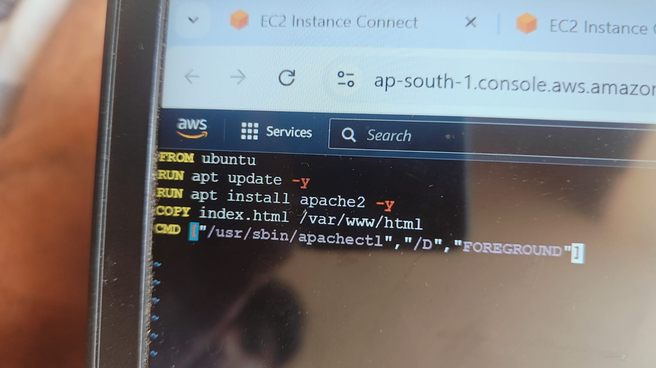

**GO TO GOOGLE**

* HTML LOGIN PAGE
* TRY IT YOURSELF
* MODIFY H2 AS SKYWAVES SOFTWARE PVT LTD
* RUN AND COPY

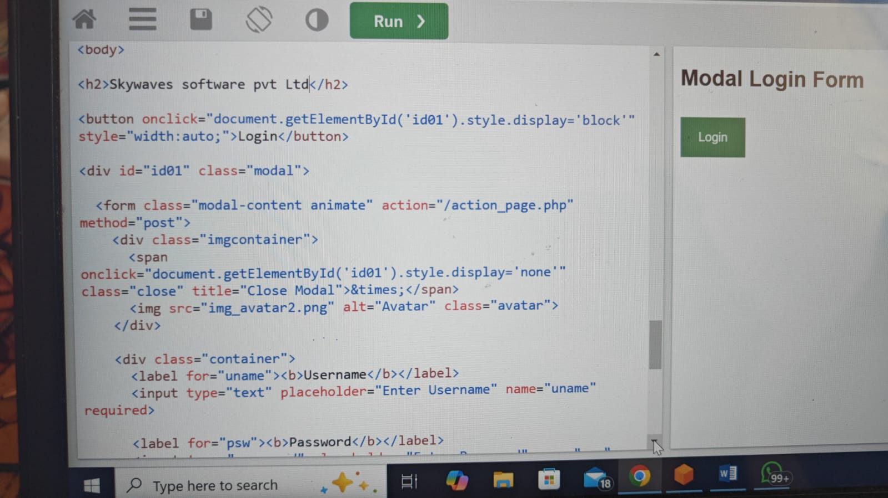

**GO TO SERVER**

* **Vi index.html**

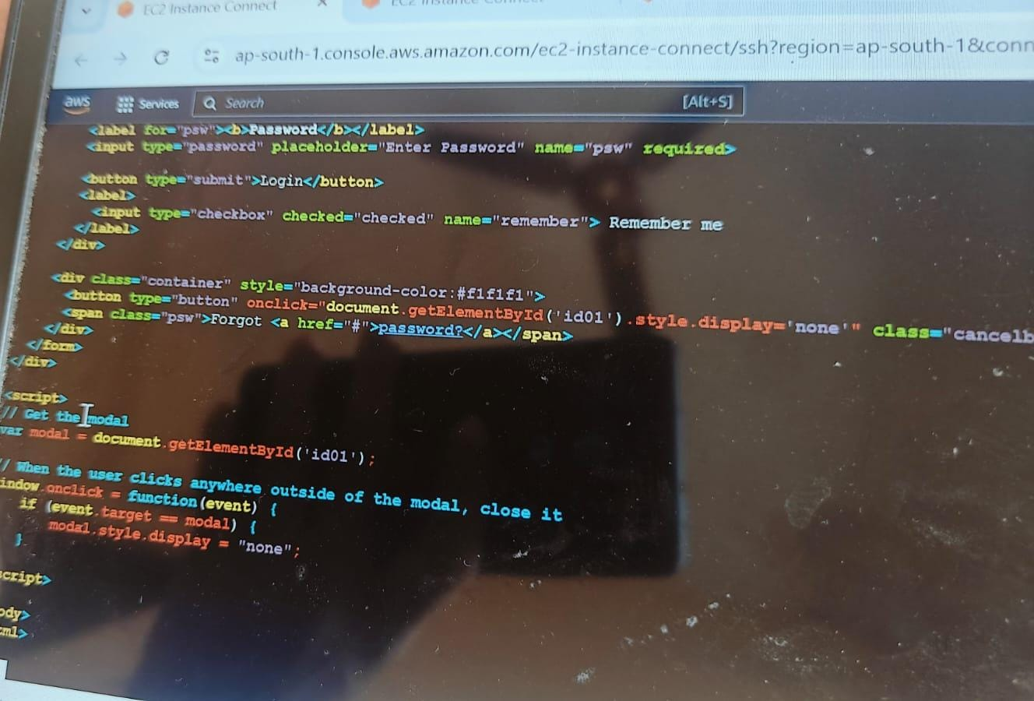

* **Ll**
* **Vi dockerfile**

**GO TO SLAVE 2**

* **Vi dockerfile (copy commands and paste in server docker file)**

**GO TO SERVER**

* **Docker build –t image .**
* **Docker service ls**
* **Docker images**
* **Docker service create –name ram –replicas 3 –publish 84:80 image**
* **Docker ps**

Copy public ip and check url with 84

GO TO SERVER

Docker service ls

GO TO SLAVE1

* Docker ps

GO TO GOOGLE

* Dockerhub
* Login

GO TO SERVER

* Docker login
* Username
* Password
* Docker images

GO TO DOCKERHUB

* Create repository
* Name (docker_swarm-repo)
* Descrbtion(for adding the login page)
* Public create

GO TO SERVER

* Docker tag image name (paste reo name)
* D0cker images
* Docker push (repo name)
* Then iamage was created in dockerhub we can check

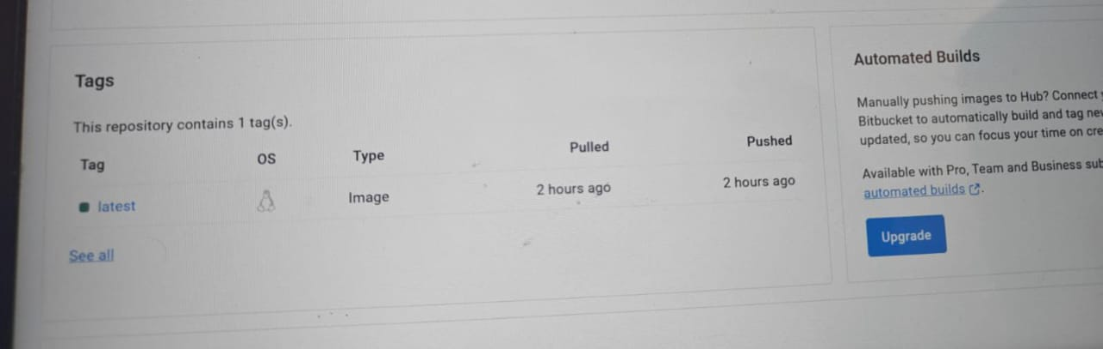

* Docker service create –name ramu –replicas 10 –publish 90:80 image
* Docker ps
* By copying public ip and imageaddress 90 we can check through url
* Docker ps
* Docker stop cont id
* Docker ps
* Docker service ls

Go to slave 1 and 2 we can check containers

* Docker ps

GO TO SERVER

* Docker ps
* Docker ps –a

